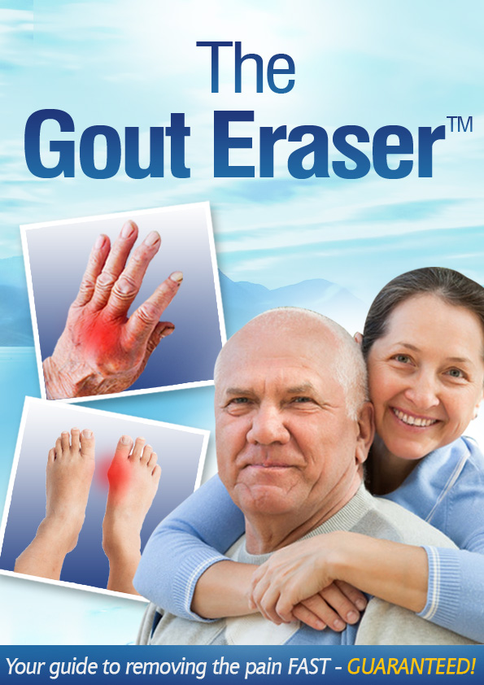

Copyright © GoutEraser.com

All rights reserved. No part of this digital book shall be reproduced, stored in a retrieval system, or transmitted by any means, electronic, mechanical, photocopying, recording, or otherwise, without written permission from the publisher.

No patent liability is assumed with respect to the use of the information contained herein. Although every precaution has been taken in the preparation of this digital book, the publisher assumes no responsibility for errors or omissions. Nor is any liability assumed for damages resulting from the use of the information contained herein.

Trademarks

All terms mentioned in this digital book that are known to be trademarks or service marks have been appropriately capitalized. The publisher cannot attest to the accuracy of this information. Use of a term in this digital book should not be regarded as affecting the validity of any trademark or service mark.

Warning and Disclaimer

Every effort has been made to make this digital book as complete and as accurate as possible, but no warranty or fitness is implied. The information provided is on an “as is” basis. The author and the publisher shall have neither liability nor responsibility to any person or entity with respect to any loss or damages arising from the information contained in this digital book.

You should contact professionals and/or experts for assistance and advice as necessary to safely and properly complete and implementation of the methods described in digital book.

You are responsible for your actions, and agree to indemnify and/or hold harmless GoutEraser.com™, its officers, directors, employees, agents, licensors, suppliers, and any third party information providers to the Service for and loss, injury, death, claim, judgment, suit, proceeding, damages, costs and/or expenses of any nature whatsoever arising from any action taken by you when using or misusing the information in this digital book, our website, and email communication with the owner of the website and author of this book (including but not limited to the personal consultations). The author is not a doctor and you should always consult with a doctor before trying any remedy or treatment. The information contained in this book is not a substitute for medical advice and treatment. You agree to read and use this book at your own risk.

Moreover, by reading this digital book, you CONFIRM that you have READ, UNDERSTOOD, and ACCEPTED fully (without any exceptions) our "Terms & Disclaimer" found at:

<http://www.gouteraser.com/terms.html>

TABLE OF CONTENTS

What You Will Find in this eBook 7

Introduction – Understanding Gout and Inflammation 9

What is Gout? 9

Acute Gout 10

Chronic Gout 11

Chapter One: Causes and Stages of Gout 13

What causes Gout? 13

How Much Protein Do I Need? 14

What Foods are good for Gout? 15

Chapter Two: Gout Statistics, Signs and Symptoms and Risk Factors 16

How common is Gout? 16

Who Can Get Gout? 17

Stages of Gout 17

Signs and Symptoms of Gout 20

Is there any particular pattern of gout symptoms? 21

How You Can Diagnose Gout 21

Further Tests for Diagnosing Gout 22

Chapter Three: The Anti-Gout Diet 24

Some Interesting Historical Facts 24

Current Medical Research 24

Specials Recommendations 25

Sample Anti-Gout Diet Menu 27

What Foods to Avoid Entirely 28

Does Beer Increase the Risk of Gout? 30

Wine Can Create Problems Too 32

The Best Diet Advice for Gout – Eat less Meat 34

Why You Should Avoid Fructose and Other Sugary Foods? 36

Avoid/Limit Your Intake of Refined Carbs 37

What You Should Include In Gout Friendly Diet 37

Chapter Four: Gout and Exercise 40

Benefits of Exercise for Gout Patients 40

How Can I Exercise – My Joints are so stiff! 41

What Kind of Exercises Can You Perform 42

Aim for Some Kind of Physical Activity Every Day! 43

Range of Motion Exercises 44

What is Range of Motion? 44

Big Toe Exercises 46

Lower Body Passive ROM Exercises 48

Range-Of-Motion Exercises to Improve Hand Mobility 54

Beat Gout Pain with Water Walking 58

Deep Water Walking 59

Gentle Strength Training Exercises for People with Gout 60

Chair Stand 61

Yoga Stretches 61

Pilates 61

Chapter Five: Managing Gout with Lifestyle Changes 62

Chapter Six: Natural remedies to treat Gout 65

Conclusion 71

# What You Will Find in this eBook

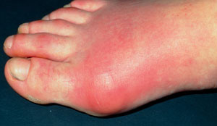Gout is a condition characterized by elevated uric acid levels in blood. This leads to the question “where does uric acid come from and what exactly causes gout?”

Well, a number of factors increase uric acid levels in blood, but your body is able to keep things under control. However, **you develop gout when your body is unable to clear excess uric acid from blood.**

This ebook will show you everything you need to know about gout and inflammation and how simple changes can help you deal with the pain of gout once and for all – 100% naturally. That’s right, free of any side effects of medications and synthetic substances. Okinawans have been doing these for centuries, and with this book, you too will be able to rid yourself of gout; just like Kassie helped me get rid of mine.

The Gout Eraser is the culmination of Sofia’s Okinawan knowledge, together with extensive research both of us conducted (in fact you’ll find up-to-date medical research and publications cited in this book). The Gout Eraser has been especially designed to set you on the path to living an active life which is gout- and inflammation-free. This guide is concise, yet it is the most comprehensive resource designed for the gout sufferer. You will know how simple changes to how you live can help you eradicate the pain and inflammation associated with gout.

*Often conventional treatments do not manage gout effectively*. This guide on the other hand sets the record straight on the best and most effective natural ways to treat gout attacks and more importantly, manage underlying condition, in order to prevent gout attacks from ever happening again.

**What you will learn here:**

1. The best natural methods that can reduce inflammation and manage gout attacks forever.

2. How diet and lifestyle changes can affect gout.

3. Gout causes, symptoms and risk factors

4. Practical advice that you can immediately use to improve your gout as well as your health.

So what are you waiting for? Continue reading to find out more.

# Introduction – Understanding Gout and Inflammation

## What is Gout?

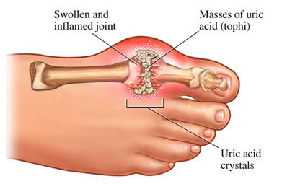Gout is one of the most painful forms of arthritis. As stated earlier it is an inflammatory type of arthritis caused by buildup of uric acid crystals. Pain and inflammation attacks occur when uric acid present in blood crystallizes in the joints. What’s sad is that recurring inflammation and gout attacks can even lead to **permanent joint damage**.

Uric acid is the **waste product created when your body breaks down purines** – a type of protein found in many foods and your cells. Normally uric acid is present in our body and is easily excreted by the kidney. However people with gout cannot maintain uric acid in dissolvable form. When uric acid level is high, insoluble crystals start depositing in the joints causing inflammation and gout.*

*\*It is important to understand that not everyone with high levels of uric acid will develop gout. More details on symptoms and causes of gout are coming up in the next chapter.*

## Acute Gout

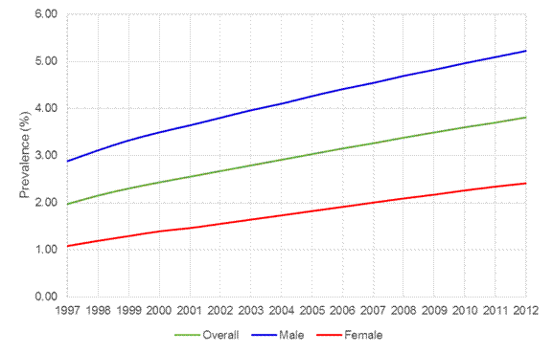Studies indicate that there has been a worldwide increase in the frequency of gout. And this can be attributed to changes in diet and lifestyle. Acute gout perhaps is one of the most painful conditions experienced by humans. It is triggered by the crystallization of uric acid within the joints and is often associated with hyperuricemia (elevated levels of uric acid in blood).

This type of gout usually involves one joint – often the ‘big toe.’ Spontaneous attacks may begin at night and **can be triggered by alcohol use, a diet rich in purines, trauma or some medications**.

**The affected joint (s) will be swollen, tender and red.**

Early attacks of acute gout usually subside after three to ten days. However in some cases, these attacks can last even longer, become more intense, occur more frequently and involve more joints.

You shouldn’t be surprised if you go to bed in good health and wake up due to sharp, intense pain in the big toe or in the heel or ankle. The pain can be so intense and acute that you cannot tolerate the lightest bed sheet on your affected joint.

Almost any joint can be affected by gout, but the most commonly affected joint is the one located at the base of the big toe. In some causes gout can affect the tendons causing the swelling of soft tissues under the joint. The underlying soft tissues can become red, ‘hot’ and swollen – remember this doesn’t occur in most other forms of arthritis.

The swelling and tenderness can eventually affected the whole ankle and foot and wearing a normal shoe over the inflamed joint may become impossible.

## Chronic Gout

Untreated acute attacks can linger on and the condition can become chronic with persistent inflammation. The uric acid crystals will continue to deposit in and around the joint leading to the destruction of the joint and soft tissues. With proper attention and simple diet and lifestyle changes most people do not progress to this advanced stage.

**So in summary:**

1. Gout is one of the most painful forms of arthritis.

2. It occurs when too much uric acid starts building up inside your body. This increase in uric acid levels can lead to:

* Sharp, tiny uric acid crystal deposits in the joints, often at the base of the big toe. Uric acid deposits usually look like small lumps under the skin
* Kidney stones

3. The big toe is the most commonly affected joint. The toe will be swollen, sore and red. It would feel very warm.

4. Gout can cause:

* Pain
* Swelling
* Redness and
* Stiffness in joints.

5. In addition to the big toe, gout can affect other joints including:

* Ankles
* Heels
* Knees
* Wrists
* Fingers
* Elbows

6. An acute gout attack can be brought on by trauma, stressful events, as well as alcohol or drug abuse.

**7. Gout is linked to increased risk of heart disease, hypertension (high blood pressure), kidney stones, obesity and high lipid levels in the blood.**

8. Early acute attacks of gouts usually get better within 3 to 10 days, even without treatment. However **untreated acute cases might become chronic with persistent inflammation.**

# Chapter One: Causes and Stages of Gout

## What causes Gout?

Gout is caused by having too much of the chemical called uric acid in your blood. Uric acid is produced when your body breaks down purines found in food and all of your body tissues.

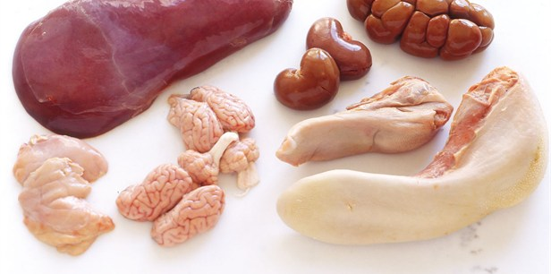**High purine foods include:**

* Offal - liver and kidneys, heart and sweetbreads
* Pheasant, rabbit, venison
* Oily fish - anchovies, herring, mackerel, sardines, sprats, whitebait, and trout
* 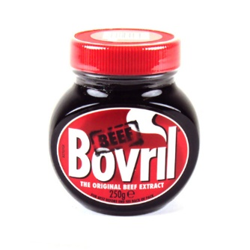Seafood - especially mussels, crab, shrimps and other shellfish, fish roe, caviar
* Meat and Yeast Extracts - Marmite, Bovril, commercial gravy as well as beer

**Moderate purine foods include:**

* Asparagus
* Beans
* Cauliflower
* Lentils
* Meat (beef, pork, lamb, veal)
* Mushrooms
* Peas
* Poultry
* Spinach
* Wheat germ/bran
* Whole grains

Normally, uric acid dissolves in the blood. It passes through the kidneys where it is filtered and then passed out of the body in urine.

But uric acid can build up in the blood when:

* The body increases the amount of uric acid it makes.
* The kidneys do not get rid of enough uric acid.
* A person eats too many foods high in purines.

As stated earlier, when uric acid levels in the blood are high, it is called hyperuricemia. Most people with hyperuricemia do not develop gout. But if excess uric acid crystals form in the body, gout can develop.

## How Much Protein Do I Need?

**Ideally, you should eat 1g of protein per kg of your body weight daily.** For example, if you weigh 75 kg, you require only 75g of protein every day unless you are advised to follow a protein restricted diet.

Some people, especially ones with liver and kidney disease are advised to restrict their intake of protein to avoid medical complications.

Protein, as you can guess is an important part of your diet. It is one of the main constituents of your muscles and is required for growth and repair of cells. Protein also functions as an energy source and helps manage your blood sugar level.

If you want to reduce your risk of developing gout or want to improve the symptoms, it is important that you combine both animal and plant protein sources. That’s right. Purines are found in both vegetarian and animal sources of protein and controlling your diet is one of the easiest ways to manage gout symptoms.

**Studies show that vegetarian purine content, such as that found in lentils is much less likely to lead to gout.**

## What Foods are good for Gout?

**Research shows that consuming a diet rich in vitamin C can reduce your risk of developing gout**. Simply put, taking vitamin C supplements can reduce blood uric acid levels and you are less likely to develop gout.

Remember that certain foods such as cherries help remove uric acid from your body and reduce the inflammation that occurs with the condition. Eating a balanced diet and more importantly, eating foods that are good for gout can help you manage the condition more effectively. More details about ‘anti-gout’ diet are coming up later in the eBook.

# Chapter Two: Gout Statistics, Signs and Symptoms and Risk Factors

## How common is Gout?

According to the Centers for Disease Control and Prevention[1]:

* The prevalence of gout among US adults in 2007–2008 was 3.9% (8.3 million individuals) using nationally representative data (NHANES) from 2007–2008.
* The prevalence of gout among men was 5.9% (6.1 million), and the prevalence among women was 2.0% (2.2 million).
* The prevalence of gout increased over the past 2 decades by an estimate of 1.2 percentage points.
* The incidence of gout among African-American men was almost twice that among men of European descent (310 vs. 180 per 100,000 person-years; follow up period 26 to 34 years). The cumulative incidence of gout was 10.9% among African-American men and 5.8% among men of European descent.
* A Rochester Epidemiology Project study showed an increase in the incidence of gout from 45.0 per 100,000 in 1977–1978 to 63.3 per 100,000 in 1995–1996. Male to female ratios were 3.3 to 1 at both time periods. Considering primary gout (excluding people with gout on diuretics), the incidence of gout increased from 20.2 to 45.9 per 100,000.

## Who Can Get Gout?

According to American College of Rheumatology, gout affects more than three million Americans. The condition and painful symptoms is more complicated in men and post-menopausal women. People with kidney disease are also more prone to develop the condition.

Modifiable risk factors include high blood pressure, high blood cholesterol and triglyceride levels and high blood glucose level. It is seen that gout has a strong genetic component and is seen to run in families.

So, you are more likely to develop gout if you:

* Have a family history
* Are a male
* Are overweight or obese
* Drink too much alcohol
* Eat purine rich foods excessively
* Have enzyme deficiency that makes it harder for your body to breakdown purines
* Use prescription medicines such as aspirin and diuretics

## Stages of Gout

Gout as stated earlier is a common form of inflammatory arthritis. It may continue for long period followed by intense flares for weeks and months before becoming chronic.

The condition usually is caused by an uncontrolled metabolic disorder known as hyperuricemia. Too much uric acid in blood leads to tiny, sharp crystals depositing in the joints.

Gout can happen in four stages.

**Stage 1: Asymptomatic Gout**

During the first stage, deposition of uric acid crystals happens in the tissues and joints, but people have no obvious symptoms of gout. While you won’t feel any pain or discomfort, the deposition of crystals will continue to cause joint damage.

**Stage 2: Acute Gout**

Acute or sudden flares occur when gout advances to the second stage and the uric acid crystals in the joint(s) cause acute inflammation.

This sudden occurrence or attack is characterized by pain, redness, swelling, and warmth which may last from days to weeks. You may experience mild or excruciating pain during this stage and most initial attacks occur in lower extremities.

Uric acid levels may be normal in about half of patients that report an acute flare.

You also need to remember that the condition may appear differently in people over 50. Gout in elderly can affect many joints at one time. Uric acid or urate crystals would deposit and cause pain and inflammation in the big toe, but they might also affect other critical joints such as knees, wrist, feet and ankles.

Acute flare-ups mostly happen during the night and can severely disable movement of the affected joint.

**Stage Three: Interval or Inter-critical Gout**

Inter-critical segments or the third stage of gout may occur after an acute flare has kind of ‘calmed down’. Simply put, you may enter the third phase or interval phase where the condition would be inactive clinically. But you need to remember that the condition may be inactive right before the next acute flare-up.

During this inter-critical phase, you will continue to have hyperuricemia, which results in continued deposition of uric acid crystals in tissues and resulting damage. These transition segments tend to become shorter as the disease progresses.

As stated earlier, this inter-critical stage is more like the calm in the eye of a storm. There would be no symptoms or signs and the condition can lie dormant between attacks.

As you can guess, this phase is usually a pain-free experience. However the uric acid crystals that continue to buildup in your blood and joints have other plans. What’s shocking is that the inter-critical phase can last for several months or years.

To reduce the chances of acute flare-up, you should continue to right eat during the inter-critical phase. Also, you should continue to drink plenty of water and take prescribed medicines (if any) regularly. You should also try to maintain an active lifestyle and lose a few pounds to ease your joints and prevent future acute flare-ups.

**Stage Four: Chronic Gout**

Chronic gout is characterized by chronic arthritis. Your joints would be sore and painful. Also, you might notice lumps of uric acid crystals deposited in ‘cooler areas’ of the body such as ears, elbows and even distal finger joints.

## Signs and Symptoms of Gout

The main symptom of gout is a sudden attack of severe pain in one or more joints, typically your big toe.

Other symptoms can include:

* The joint feeling hot and very tender, to the point of being unable to bear anything touching it
* Swelling in and around the affected joint
* Red, shiny skin over the affected joint
* Peeling, itchy and flaky skin as the swelling goes down

The intense pain can make getting around difficult.

**Which joints can be affected?**

Gout can affect almost any joint and can occur in more than one joint at the same time.

The joints towards the ends of the limbs tend to be affected more often. You would notice the symptoms to be the most severe in the:

* Toes – particularly the big toe
* Ankles
* Knees
* Fingers
* Wrists
* Elbows

If gout is left untreated, it's likely to affect more joints over time.

## Is there any particular pattern of gout symptoms?

Attacks of gout tend to:

* Occur at night, but they can happen at any time
* Develop almost instantly – the pain can become intense in just over a few hours
* Last between three and 10 days. After ten days have passed, the affected joint should start to return to normal, but the problem can persist for a longer time if treatment isn't started early

Remember that gout attacks can come back when you expect them the least. Furthermore, you may experience attacks every few months or years. It's difficult to predict how often attacks will occur and when exactly they will happen. It is also seen that the symptoms of gout become more severe if the condition is left untreated for a long period of time.

## How You Can Diagnose Gout

As you can guess, your doctor or healthcare provider will suspect gout based on your symptoms. If needed, your GP might recommend additional tests to confirm the diagnosis. Remember that your GP might ask you to get the additional tests done to rule out other possible causes that might cause inflamed and sore joints.

If you experience gout symptoms, you need to visit your doctor. Your healthcare provider will then evaluate your medical history and examine the affected joints. You will also be asked questions related to your symptoms and lifestyle particularly if your diet includes high intake of alcohol, purine rich foods such as red meat.

## Further Tests for Diagnosing Gout

It is important to remember that a number of other medical conditions can trigger gout-like symptoms. Your healthcare provider may recommend further tests to rule out medical conditions and confirm the diagnosis of gout. These further tests include:

**1. Joint Fluid Test**

As the name suggests, a small sample of fluid will be taken from the affected joint. The sample is then sent to the laboratory for further analysis. If your fluid sample contains small uric acid crystals, gout will be confirmed. Sometimes joint fluid is tested for infections to rule out the possibility of septic arthritis.

**2. Blood Test**

A simple blood test, also known as serum uric acid test is done to measure the level of uric acid in your blood. Elevated or high levels of uric acid in blood are associated with gout.

An important thing to remember is that your healthcare provider might wait for at least two or three weeks before this blood test is carried out. This is because uric acid levels in blood might not be raised during the gout attack. Uric acid levels might drop when tiny uric acid crystals continue to deposit in the joints.

**3. X-ray**

Well, gout is a condition that cannot be detected using x-rays. But your doctor may recommend an x-ray to rule out other medical conditions that might limit joint mobility or cause buildup of calcium crystals.

Sometimes x-ray is done to assess the extent of joint damage caused by repeated attacks or chronic gout.

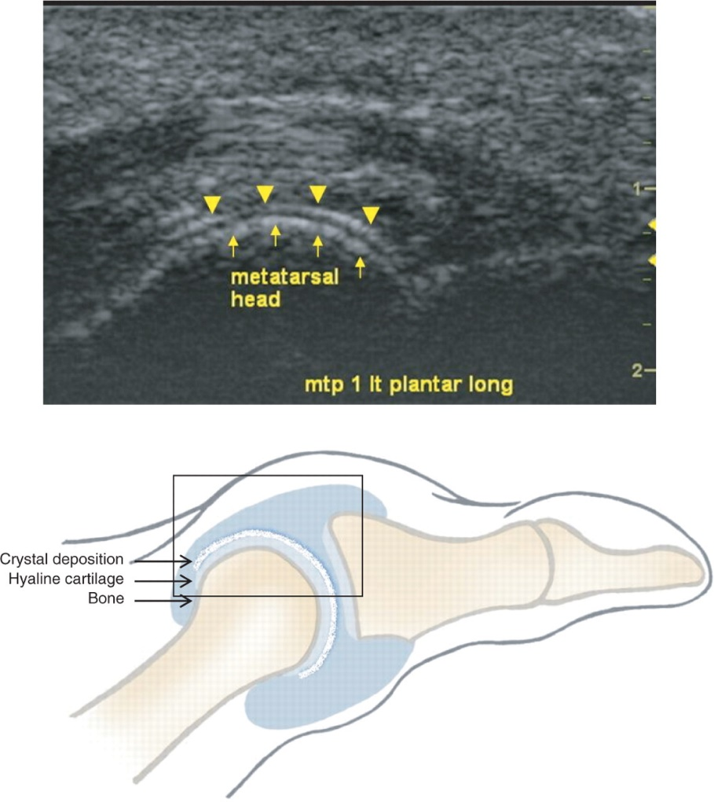**4. Ultrasound scan**

An ultrasound scan can detect uric acid crystals that are deposited deep in the joints and are not detectable during a simple physical exam. This scan is relatively safe and simple and is frequently used to detect uric acid crystals in the affected (painful) joint(s).

# Chapter Three: The Anti-Gout Diet

We discussed that gout is a painful form of arthritis and the condition occurs when uric acid levels increase in blood. This increase in uric acid causes tiny uric acid crystals to form and start depositing in your joint(s).

## Some Interesting Historical Facts

For centuries, gout was associated with the elites. In fact it was considered a disease that only affected wealthy people. People who could actually afford to eat meat and drink alcohol suffered from the condition. Even the earliest gout treatments focused on eliminating all foods that had moderate to high amounts of purine.

## Current Medical Research

Recent medical research suggests that food plays an important part in controlling uric acid levels in blood. This finding has also created a clearer picture of the role of diet in gout management.

This section focuses on the Anti-Gout diet – a diet that will help you manage gout and alleviate the painful symptoms. In addition, most goals of the anti-gout diet are same as what you would follow for any healthy diet.

For example:

1. You have to maintain healthy body weight. Losing extra pounds will reduce the overall stress on your joints.

2. Eat more of complex carbohydrates

3. Keep yourself hydrated by drinking more water. Ideally, you should consume at least 8 to 16 glasses of water.

4. You have to cut down on saturated fats, i.e. reduce your intake of red meats, high-fat dairy and fatty poultry.

5. Add lean protein to your diet along with low-fat, fat-free dairy products.

## Specials Recommendations

**1. High-purine vegetables**

Numerous studies show that veggies high in purines might not necessarily increase your risk of developing gout. On the other hand, you should eat a healthy diet based on fresh fruits and vegetables and your meal plans can include high-purine vegetables such as spinach, peas, cauliflower and even asparagus, however in moderation.

**2. Organ meat**

Liver, kidney and other glandular meat have high purine content which can worsen your condition.

**3. Seafood**

Not all seafood causes problems. You need to avoid seafood that is high in purines such as:

* Anchovies
* Sardines
* Scallops
* Mackerel
* Tuna
* Herring
* Mussels
* Trout
* Haddock

**4. Alcohol**

The way alcohol is metabolized inside your body is thought to increase the production of uric acid. You also need to remember that alcohol causes dehydration and it may increase your risk of gout and recurring attacks.

**5. Coffee**

There’s evidence that moderate coffee consumption can reduce your risk of gout. However, drinking too much caffeinated drinks might trigger other medical conditions. Make sure you consult your doctor and talk about whether coffee is right for you before consumption.

## Sample Anti-Gout Diet Menu

Here's a look at what you might eat during a typical day on a gout diet:

Breakfast

* Whole-grain, unsweetened cereal with skim or low-fat milk
* 1 cup fresh strawberries
* Coffee
* Water

Lunch

* Roasted chicken breast slices (2 ounces) on a whole-grain roll with mustard
* Mixed green salad with balsamic vinegar and olive oil dressing
* Skim or low-fat milk
* Water

Afternoon snack

* 1 cup fresh cherries
* Water

Dinner

* Roasted salmon (3-4 ounces)
* Roasted or steamed green beans
* ½ cup whole-grain pasta with olive oil and lemon pepper
* Water
* Low-fat yogurt
* 1 cup fresh melon
* Caffeine-free beverage, such as herbal tea

**What exactly is a Gout-Friendly Diet?**

The main goal of anti-gout diet is to reduce painful swelling/inflammation of joints and more importantly, prevent recurring attacks. The results of anti-gout diet can vary significantly depending on:

* Your age
* General health
* Medical history
* Severity of the condition

The good news is that you can manage gout attacks through a healthy diet and lifestyle. If you’re using any prescription medication – anti-inflammatory drugs, or drugs or lower levels of uric acid in blood, consult your doctor before making any changes in your diet or lifestyle.

## What Foods to Avoid Entirely

According to the American College of Rheumatology, a diet that has an excessive amount of the following foods can lead to gout:

* Seafood
* Red meat
* Sugar / sugar loaded drinks
* Alcohol

Eating a balanced, gout-friendly diet not only helps control uric acid levels in the body, it also helps promote overall health. Here’s a quick description of the foods you need to avoid to give you a better idea.

**1. Scallops**

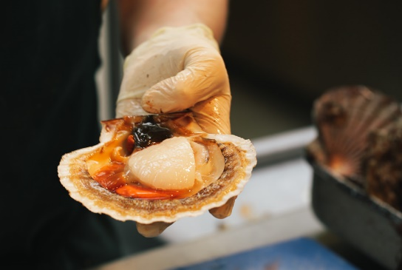You need to cut back on scallops particularly when gout is active, i.e. during a flare-up. These delicious treats are rich in purines, which is broken down and converted into uric acid inside your body.

While you can choose seafood when gout is under control, it is still a smart idea to keep seafood intake to a minimum. Remember, seafood should be only reserved for occasional treats.

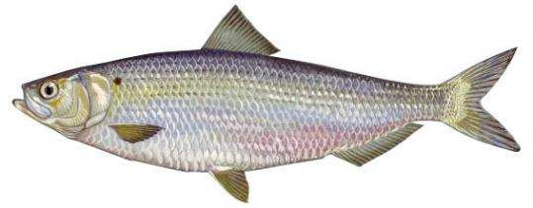**2. Herring**

Herring is a rich source of omega 3 fatty acids, but it shouldn’t be on your menu if you have gout. That’s right. Herring, tuna and even anchovies should be avoided during the condition. On the other hand, if you crave seafood, go for safer choices such as shrimps, lobsters, and crab.

**3. Beer/Alcohol**

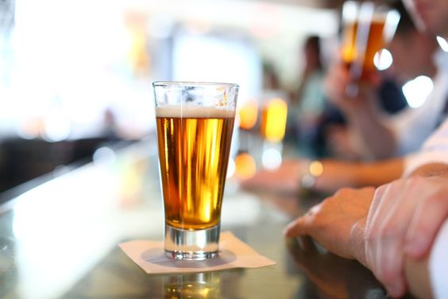**Not only does beer increase your uric-acid level, it also makes it more difficult for your kidneys to get rid of this problem causing agent.** Wine is comparatively less problematic, but as you can guess heavy drinking is a bad idea for everyone, and people who suffer from gout are no exceptions.

What happens is that alcohol content in beer and spirits disrupts the ‘smooth’ excretion of uric acid from the body. When uric acid levels in blood get too high, tiny crystals start depositing around the joints which worsens your condition.

To prevent gout symptoms from getting worse, stick to these guidelines:

* Avoid alcohol when having an attack
* Always avoid beer, even when asymptomatic
* Limit all other alcohol consumption when asymptomatic

### Does Beer Increase the Risk of Gout?

For ages, gout was known as the “disease of kings” thanks to overindulgence in meat and alcohol. But now it is proven that beer is one of the biggest culprit beverages!

The [following excerpt quoted directly from Harvard Health Publications](http://www.health.harvard.edu/family-health-guide/alcohol-increases-the-risk-of-gout) shares the results of an interesting large study.

***Men who drink alcohol, particularly beer, may double their likelihood of developing gout.*** *Humankind has known about this link between alcohol and gout for ages through anecdotal evidence, but now the results of a medical study verify the connection.*

*Gout is a form of acute arthritis marked by severe pain and inflammation in the joints, particularly the big toe. Episodes of gout strike suddenly without warning. Severe cases of gout may lead to major disability and even kidney failure. More men experience the condition than women, although the difference is less dramatic among the elderly. Researchers believe that while both hereditary and environmental factors lead to gout, environmental causes, such as regular alcohol consumption, are behind the increase in cases of gout in the past thirty years.*

***In a study published in The Lancet medical journal this spring, researchers followed over 47,000 male medical professionals with no history of gout for up to 12 years. By the end of the study close to 2 percent of the men had experienced attacks of gout.***

***Men who drank the most alcohol daily had twice the risk of developing the disorder as men who did not drink. Beer drinkers increased their risk by 50% for every daily serving, while those who drank hard liquor increased their risk by 15% for each drink.***

*Men who drank wine did not appear to increase their risk for gout, although few men had more than two glasses of wine daily so these results are less conclusive.*

*The researchers believe beer consumption leads to gout because of its high purine content. Through the process of digestion, the purine compound breaks down to form uric acid. Normally, uric acid leaves the body through urine. But if the kidneys are unable to process all of the uric acid, levels in the blood become too high. The uric acid may then form crystal deposits in the joints. These deposits are the cause of gout.*

*While powerful medications are available to treat gout, it makes sense to try to lower your risk of developing the disease in the first place. You may be able to ward off gout attacks by avoiding excessive consumption of alcohol and choosing your drink wisely.*

### Wine Can Create Problems Too

Beer is known to increase the risk of gout but the following excerpt from the Arthritis Foundation blog reveals that wine can create problems too.

*Beer and hard liquor have long been known to increase the risk of gout, the most common form of inflammatory arthritis, but* ***according to a 2014 study in “The American Journal of Medicine”, wine also can contribute to recurrent gout attacks.[2]***

*Gout occurs when excess uric acid builds up around joints – often in the big toe, but also in the feet, ankles, knees, wrists and elbows – leading to episodes of intense pain, redness and swelling. It affects more than 8 million adults in the United States, and the numbers are rising sharply, due mainly to obesity and other lifestyle factors.*

***In the 2014 study, 724 gout patients completed questionnaires every few months as well as after gout attacks about their diet, medications, exercise and number of alcoholic drinks consumed.***

*The researchers compared what a participant consumed on an average day to what that participant had consumed in the 24 hours before a gout attack. Researchers looked at the overall effect of alcohol on gout attacks as well as the individual effects of wine, beer and liquor, while taking diet and other factors into account.*

***Results showed that a single serving of wine, beer or liquor (either straight or in a mixed drink) in a 24-hour period didn’t significantly increase the chance of repeat gout attacks. But consuming more than one to two drinks a day did – by 36%. With two to four drinks, the risk rose 50%, and it continued to rise with the amount of alcohol consumed.***

***When the three types of alcohol were compared, wine was actually a significant trigger.***

*Drinking between one to two glasses of wine in the 24 hours before the attack raised the risk of recurrent attacks by 138%; in other words, it more than doubled the risk of a gout attack, compared to drinking no wine.*

*The researchers point out that these results apply to men; findings for women are less clear, mainly because so few women were in the study. Study author Tuhina Neogi, MD, a professor at Boston University School of Medicine, says, “But the patterns of alcohol’s effects on risk of gout attacks were generally similar to [those] seen in men.”*

*Dr. Neogi says, “Based on this study,* ***I would counsel gout patients that any type of alcohol may trigger an attack; it’s not just beer or liquor but also wine****. Each patient is different, so a ‘safe’ limit can’t be uniformly set, but obviously abstaining from alcohol would avoid any risk of attack due to [its use].”*

**4. Red meat**

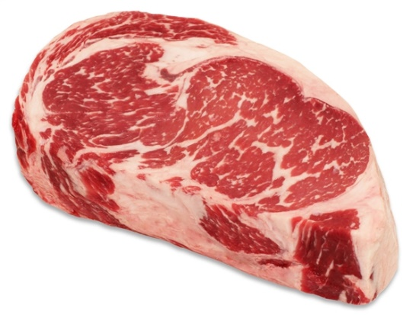Simply put, all kinds of meat have different purine content. Red meat isn’t a good choice, but you can eat lean red meat once in a while. **Remember, chops are a better choice than leg meat when it comes to purine content.** If you want to include healthy meat protein sources in your diet, go for white meat instead.

### The Best Diet Advice for Gout – Eat less Meat[3]

*In a* [*2004 study published in the New England Journal of Medicine*](http://www.arthritis.org/about-arthritis/types/gout/articles/purine-foods-gout-attack.php?_ga=1.18025786.2047234926.1473065888)*, researchers evaluated the relationship between the intake of purine-rich foods, dairy foods and protein and the incidence of gout in a cohort of 47,150 men who had no history of gout at baseline. They found that increased meat and seafood intake was associated with approximately a 50 percent higher risk of gout development over the 12-year study period.*

*While the study was the first to show that consuming high-purine foods could increase the risk of gout development, researchers had long suspected that a diet rich in high-purine foods could increase the risk of gout attacks.*

*A study published eight years later in Annals of the Rheumatic Diseases offered proof. The study, which involved more than 630 participants with a history of gout within the previous 12 months, showed a direct association between purine intake and gout attacks.* ***In fact, eating a lot of purine-rich foods – like red meat, organ meat, certain fish and vegetables – over a short period of time increased the risk of a gout attack almost fivefold compared to the risk when eating fewer purine-rich foods.***

*The authors conclude that ingestion of purine-rich foods can actually trigger a gout attack within days – and that the risk rises as more purines are included in the diet.*

*“Our study showed that risk of recurrent gout attacks increased almost 40 percent if intake of purine went from less than 1 gram to 1.75 grams over two days,” says study co-author Yuqing Zhang, professor of medicine and public health at Boston University. The fivefold increase in gout-flare risk came at purine ingestion levels about twice that level – and the risk persisted even in those taking the uric acid-lowering agent allopurinol.*

**5. Turkey**

Again turkey, goose and other ‘wild’ sources have higher purine content than other food sources so it is best to avoid them. That’s right. If you’re prone to gout, keep your intake of wild meat to a minimum.

**When you talk about protein sources, chicken and duck are the safest choices.**



**6. Sugary drinks**

You should try your best to **avoid drinks that are loaded with sugars such as high-fructose corn syrup**. On the other hand, fruity drinks and sodas that are too sweet aren’t a good choice either. Simply put, artificial fruit drinks not only are an easy way to pack on pounds; they will also stimulate your body to produce more uric acid.



*A* [*22-year study of 80,000 women*](https://www.hsph.harvard.edu/nutritionsource/sugary-drinks-fact-sheet/) *found that those who consumed a can a day of sugary drink had a 75% higher risk of gout than women who rarely had such drinks. Researchers found a similarly-elevated risk in men.[4]*

### Why You Should Avoid Fructose and Other Sugary Foods?

The debate about the dangerous effects of sugar and sugary foods on uric acid levels in the body is going on for decades. However, medical experts agree that high intake of sugar is linked to obesity – a major risk factor for gout.

***Can sugar drinks, particularly fructose-rich beverages increase your risk of developing gout?* Well unfortunately, the answer is a big yes!** Fruity drinks might not contain high amounts of purines, but they are loaded with fructose which increases your uric acid levels.

No matter how tempting sodas, fruit drinks and soft drinks might look, they are better left untouched. You should try to cut down on the intake of soda and soft drinks and increase your daily water intake to help your kidneys flush out toxins and uric acid from blood. Furthermore, you should make more room for low-fat dairy options and plant based purines in your diet.

### Avoid/Limit Your Intake of Refined Carbs

Refined carbohydrates include:

* 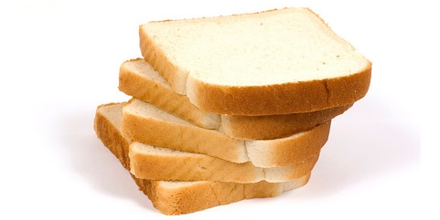White bread
* Cakes
* Candy
* Pasta (except for whole grain)

Refined carbohydrates also increase your risk of developing gout and must be avoided.

**7. Liver**

Organ meats, such as liver, kidneys, and sweetbreads, are a major no-no if you have gout.

## What You Should Include In Gout Friendly Diet

Consuming a low purine diet can help you lower uric acid levels in blood. What’s better is that a low purine diet can also prevent symptoms of gout from ever coming back; **hence a low purine diet is essential for getting rid PERMANENTLY of gout.**

Beans and legumes are excellent plant-based protein sources that can meet your daily requirements.

Foods to Include Daily:

* Beans and lentils
* Legumes
* Fluids, especially water
* Low-fat or fat-free dairy (max 16-24 oz daily)
* Whole grains (like oats, brown rice, and barley)
* Quinoa
* Sweet potatoes
* Fruits and vegetables

**So in summary:**

Eating During Acute Gout Attack:

1. Avoid purine rich foods such as:

* Anchovies
* Beer
* Bouillon
* Goose
* Heart
* Kidney
* Liver
* Heart
* Meat extracts/broth
* Mincemeat
* Herring
* Mackerel
* Mussels
* Caviar
* Scallops
* Sardines
* Sweetbreads
* Yeast: both baker’s and brewers

2. Consume 8 to 16 glasses of water daily

3. Avoid beer, wine and other alcoholic drinks

4. Limit sugar intake and avoid fruit juices and other sugared drinks

5. Eat animal protein (meat, fish, and poultry) in moderation (max 4 to 6 ounce per day)

6. Opt for low-fat and non-fat dairy products. Nut butters such as peanut butter and almond butter are also preferred.

**Eating During Remission (to avoid relapse)**

1. Drink at least 8 to 16 glasses of water

2. Limit sugary drinks, fruit juices and alcohol intake. Some patients report that consuming fructose loaded foods such as apples, pears and honey can also increase gout risk.

3. Consume foods with moderate and low purine content.

4. Maintain a healthy body weight

5. Avoid prolong fasting or high-protein diets for rapid weight loss.

# Chapter Four: Gout and Exercise

If you have gout, the first step is to reduce the pain and inflammation. It is seen that controlling your weight through healthy diet and exercise can help prevent gout attacks.

Remember that exercise programs should always be planned in consultation with your doctor, or healthcare provider.

## Benefits of Exercise for Gout Patients

Gout is a common form of inflammatory arthritis characterized by extreme pain, redness and swelling in affected joints. Unlike other types of arthritis, gout attacks develop without any warning. The most commonly affected joint is your big toe, but you can experience pain and inflammation in other joints such as ankles, knees and elbows.

As stated earlier, your foremost goal should be to reduce the pain and inflammation associated with the gout attack. Once acute attack has subsided, there are a number of things that you can do to prevent another painful attack such as maintaining healthy body weight through exercise.

Regular physical exercise has many benefits for gout sufferers. Exercise can:

* Improve joint flexibility
* Build muscular strength
* Improve balance
* Prevent or manage osteoporosis, thinning of the bones and loss of bone mass by maintaining bone density
* Improve your mood
* Ease joint pain and stiffness
* Reduce joint deformity
* Improve posture
* Improve overall health and fitness
* Lower stress levels
* Prevent obesity and help maintain a healthy body weight

## How Can I Exercise – My Joints are so stiff!

Most gout sufferers have New Year’s resolutions like this. Yes, they want to be healthy and get into the habit of exercising, but there’s one thing that holds them back.

“How can I exercise when I suffer from painful joints and my body is so sensitive?” Well, you need to remember that a ***lack of exercise will only worsen the pain and inflammation and intensify the symptoms with the passage of time.***

Simply put, not exercising your joints and muscles will make them less flexible. What’s worse is that inactivity or sedentary lifestyle can speed up bone loss and intensify the painful symptoms of gout.

Regular exercise can keep you in good shape, increase your body and most importantly, help you build strong muscles and joints. That being said, here’s another thing you need to keep in mind.

**You should never try crash diets or perform high intensity exercises right away.** Losing weight too drastically or trying out some complex moves can actually have the opposite effect and even cause your uric acid levels to increase.

**Rule #1**: You should only start exercising only if the acute attack has subsided. Simply put, if your joint is inflamed (due to gout or any other reason), do not start exercising. Exercising with inflamed joints can worsen your condition and even delay recovery.

**Rule #2:** Listen to your body and build up your exercise intensity slowly.

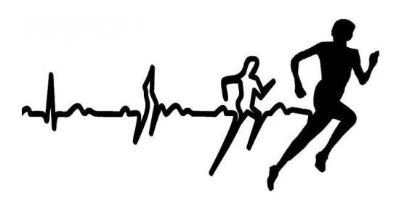Studies show that while exercising doesn’t help clear uric acid crystals from blood or break them down, it helps strengthen your joints and keeps your body weight in check which ultimately keeps you healthy.

## What Kind of Exercises Can You Perform

Ideally there are four major areas that you should be integrating in your exercise routine.

**1. Range of motion exercises**

These exercises basically keep your joints flexible and help reduce stiffness. One of the most effective exercises for your foot is to rotate your ankle slowly in a circular motion. Similarly, you can rotate other joints during the exercise such as your wrist, neck, and head.

**2. Strength training exercises**

These exercises can increase and maintain the strength of your muscles. Remember strong muscles and joints can take pressure off your bones and prevent bone loss.

**3. Stretching exercises**

Yoga and Pilates are the most popular stretching exercises that you can try to increase your flexibility as well as your muscle strength.

**4. Cardio Exercises**

As you can guess, cardio exercises improve your heart rate and boost blood circulation. You can choose low impact cardio exercises such as walking or jogging which do not put a great deal of stress on your joints. Most gout sufferers prefer to perform water exercises.

Last, **Rule #3**: Always consult your doctor or healthcare provider before starting any new exercise program. Your doctor will recommend different exercise like swimming instead of jogging to lessen the stress on your big toe. Remember, you have to watch out your foot while exercising because your big toe is the first joint to be affected and the last thing you want to experience is painful swelling on your foot due to over-exercising!

## Aim for Some Kind of Physical Activity Every Day!

Painful and stiff joints can sometimes make it difficult to exercise, but you can always try to do some kind of light physical exercise every day.

When you’re starting out, it’s important to let the inflammation subside and start slowly. That’s right. You shouldn’t push yourself too hard on day one. Instead, build up your strength and stamina steadily over a period of time.

The exercises you choose should ideally help with:

* Increasing joint mobility.

You should be able to stretch and maintain or improve the joint’s range of motion and flexibility

* Building muscle strength.

The low-impact exercises should provide stability to the joint and improve your ability to perform daily tasks

* Improving cardiovascular fitness.

Increased blood circulation can provide the inflamed and stiff joints with oxygen and nutrients which ultimately will reduce inflammation and alleviate the gout symptoms.

## Range of Motion Exercises

If you are living with gout, lack of exercise can create a vicious circle that can worsen and intensify the painful effect of this inflammatory disease. Of course gout makes your joints hurt and you are less likely to get up and get moving. But if you remain idle, your joints and muscles become less flexible. What’s worse is that your bones start losing calcium and the painful symptoms of gout amplify.

Range of Motion (ROM) exercises are designed to preserve flexibility and mobility of the joints on which these moves are performed. If you perform ROM exercises regularly, you can reduce stiffness and prevent the freezing of your joints as the condition progresses.

### What is Range of Motion?

Every joint in your body has a normal range of motion. Your joints are built in a way that they maintain their normal range of motion by being moved. It is important that you move your joints every day or they will become stiff and make it hard for you to do your normal daily activities.

As stated earlier, ROM or range of motion is the distance your joint can be moved in a certain direction. This distance or amount of freedom is usually measured in degrees.

Basically there are three main types of range of motion exercises.

1. Passive ROM

Passive ‘range of motion’ exercises involve no ‘active’ movements from the sufferer. The caregiver or physical therapist is the one moving the affected joints. Passive exercises are done to prevent stiffness of the joint from being inactive. You can perform passive range of motion exercises along with passive stretching exercises.

2. Active assistive ROM exercises

The patient moves his or her joints but with some assistance from the caregiver or physical therapist. These exercises usually are done slowly to increase the strength of the patient’s specific muscle.

3. Active Range of Motion Exercises

All movements in active range of motion exercises are performed by the patient. These exercises can be performed with or without assistance from the caregiver or the physical therapist.

Often a combination of the types of ROM exercises above will be used. For example, you can do stretching exercises yourself when you have the muscle strength to move your joints through their complete ranges. Even within a joint, the type of exercise used can vary depending on the strength of the joint and different muscle groups.

General Instructions:

1. Perform these exercises once a day when you start.

2. Do each exercise 10 times and move your joints to the point of resistance. You should feel slight resistance, but the movement should never be too painful.

3. Hold the position for about 30 seconds.

4. Always begin the exercises slowly and gradually build up frequency.

5. Move your joints only to the point of resistance. You should never try to force the movement.

6. Keep your limbs supported throughout motion.

7. Always perform the exercises slowly.

### Big Toe Exercises

You may not give much thought to your big toe when it comes to exercise, but you need to remember that strong big toes can help you balance your body and allow for a powerful push off.

Gout unfortunately affects your big toe first. This section looks at some of the basic exercises you can perform to increase the big toe’s strength, flexibility as well as range of motion.

**Pain and stiffness of the big toe joint can be reduced by performing gentle stretching and range of motion exercises of this joint.** Remember, these exercises can help you get rid of the pain and inflammation, but you should always start them after consulting your healthcare provider. If you’re having difficulty performing these exercises or your symptoms worsen, consult your doctor immediately.

**1. Gentle Stretching**

This mild, assisted range of motion exercise can be performed 10 times every day.

First grasp the affected big toe (near the base of the toe) and gently flex it upwards until slight resistance is met. Hold the position for about 5 seconds and then flex the toe downwards.

Helpful Advice:

* Repeat the exercise at least ten times, three times a day.
* Don’t hold the position longer than 5 seconds.
* You can increase the vigor and force applied to each toe gradually.

**2. Weight Bearing Exercise**

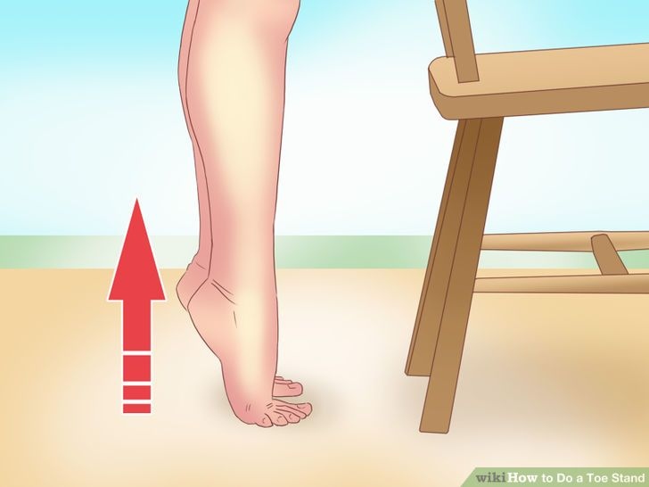Place your foot firmly on the ground and keeping the big toe on the floor, try to lift your heel up. Remember, you need to use your body weight as resistance.

Stand on your toes for about 8 to 10 seconds. Relax and repeat the exercise on the other side.

**3. Manipulation Exercise**

Grasp your forefoot firmly with one hand – your thumb should be placed on the top of the foot. Use the other hand to grasp the base of your big toe.

Now try to flex your big toe upwards while stabilizing the forefoot with your hand. Hold the position for about 10 seconds and then relax. You can repeat the exercise three times.

You can perform the same exercise by pushing the big toe downwards. Hold the position for approximately 10 seconds and repeat the step 3 times.

These manipulation exercises should be performed 2 to 3 times a day in addition to the range of motion exercises mentioned earlier.

### Lower Body Passive ROM Exercises

**1. Hip and Knee Flexion**

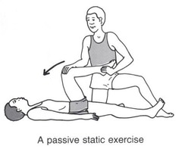This exercise requires assistance.

1. The caregiver will bend your knee and place one hand under the bent knee.

2. Your doctor/caregiver will use the other hand to grasp the heel firmly for additional support.

3. Your bent knee will be lifted slowly and moved towards the chest. Remember, you should keep your foot in line with the hip and not bend it in or out. Take care that your hip is not twisted during the exercise.

4. The bent leg will then be lowered to the starting position.

5. The same steps will be repeated on the other leg.

**2. Hip Rotation**

*This exercise also requires assistance

1. Your caregiver will place one hand on the thigh and the other hand will be placed right below your knee.
2. The caregiver or doctor will bend your knee in a way that a 90 degree angle is created at the hip.
3. You will then be asked to pull your foot slightly towards your chest and then push it away.*
4. *Remember, you should never push beyond the point of resistance, i.e. the movement should never feel painful.
5. Your leg will be lowered to the starting position and the same exercise will be repeated on the other side.

**3. Hip Abduction**

1. Your caregiver will bend your leg and carefully place one hand under your knee.
2. When your doctor or caregiver will hold your leg, the other hand will be used to grasp the heel and stabilize the hip joint.
3. The leg that is bent will be moved along the surface of the bed to create a 45 degree angle with the other leg. You need to keep your knee straight throughout the exercise.
4. Your caregiver will then move the leg back to the starting position and then repeat the same steps on the other side.

**4. Straight Leg Lifts**

This exercise is an excellent way to strengthen the quadriceps muscle in your thigh. When performed regularly, straight leg lifts will increase the stability of your knee joint and you will able to walk around comfortably. Strong thigh muscles ensure that you have complete control over your knee movements.

1. To perform this exercise, lie comfortably on the back and make sure your legs are extended fully.
2. You need to lift your leg about six inches off the ground and hold the position for about 10 seconds.
3. Lower your leg and repeat the exercise on the other side.

**5. Ankle Pumps**

This simple exercise will strengthen your ankles and you shouldn’t feel any pain while walking or performing other routine activities.

1. First, lie comfortable on your back and bend both your ankles up. Your toes should be pointing straight towards you.
2. Next, bend your ankles down and try to push your toes away from you.
3. To make this move more challenging, rotate your foot clockwise first and then anti clockwise – remember, your toes should point away from you.

**6. Thigh Squeeze**

1. Make sure you’re comfortable as you lie flat on your back.
2. Push the back of your knee down towards the floor to tighten the muscles in your thighs.
3. Hold the position for five seconds and then relax.
4. Repeat the same exercise 5 times.

**7. Leg Slides**

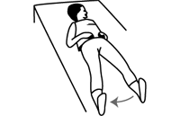First, lie comfortable on the floor and make sure your back is flat.

Now slowly slide your leg out to one side. Your knee cap will be pointed upwards.

Move your leg back to the starting position and relax.

This move is especially designed to activate the abductors and gluteus muscle. Remember strong gluteus muscles can help your pelvis remain stable while walking.

**8. Knee Bending**

1. Choose a peaceful corner of your home and sit comfortable in a stable chair.
2. Now bend your leg in a way that it is underneath the seat.
3. 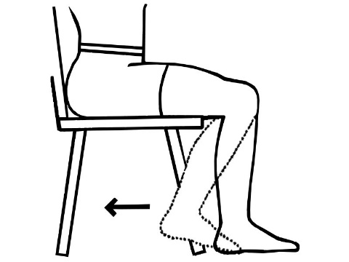Try to bend your knee back as far as possible and hold the position for five seconds.
4. Return to starting position and repeat the same steps on the other side.

**9. Prolonged Knee Stretch**

1. Sit comfortable in a chair and bend your knee back as far as possible.
2. Hold the position for 10 to 15 seconds.
3. As your knee becomes more flexible, bend forward in the chair to increase the stretch. You can also try to increase the duration of the stretch to 30, 45 and even 60 seconds.

As you can guess, this exercise focuses on improving the range of motion of your knees. If practiced regularly, this move can increase knee flexion and make routine activities such as driving and using a flight of stairs easier.

**10. Heel Slides**

This exercise focuses primarily on building hamstring strength. Furthermore it is an excellent way to improve knee flexion and range of motion.

To start, lie flat on your back and slowly bend your knee. Your foot should slide upwards towards your buttocks.

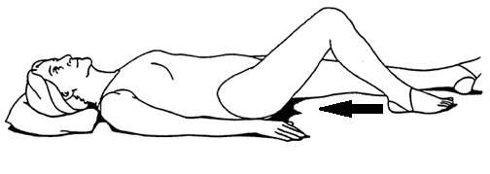Next, slowly slide your foot back to the starting position and make sure your knee cap is pointed towards the ceiling during the entire exercise.

**11. Lying Kicks**

If you’re looking for a move to build strong thigh muscle and improve knee flexion, look no further.

1. Lie flat on your back and place a rolled blanket under your knees.
2. 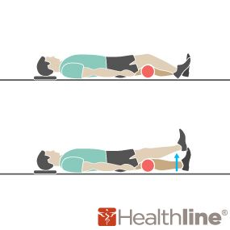Now straighten one leg and hold the position for about 5 seconds
3. Lower the leg and relax for about 5 to 10 seconds
4. Repeat the exercise on the other leg

**12. Passive Hamstring Stretch**

This exercise is one of the most effective moves to strengthen your knee joint.

1. Lie flat on your back and make sure your legs are fully extended.
2. Place your foot on a stack of pillows – remember one of your legs will be hanging freely.
3. 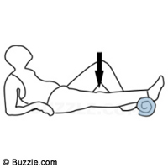Stay in the position for about 8 to 10 minutes and allow your knee to stretch gently.
4. Repeat the exercise on the other knee.

**13. Knee Straightening Stretch**

This exercise will help you increase terminal knee extension range of motion.

1. 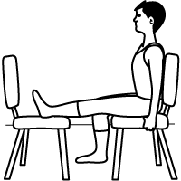Sit with your back straight and place your leg as straight as possible on an opposite ‘stable’ chair.
2. Relax your toes and keep your leg extended straight for about 10 minutes.
3. Now slowly move your leg out of the position and let it rest.
4. Repeat the step on the other leg to give it a nice stretch.

### Range-Of-Motion Exercises to Improve Hand Mobility

Stiffness, pain and soreness in your hand, wrist is annoying and it can also make it extremely difficult to do daily tasks. The following range of motion exercises can help you get your hand and wrists back in motion.

Remember that you need to move your wrist and fingers through their normal range of motion to perform your daily tasks. These exercises need to be done slowly to avoid injury.*

If you notice any discomfort, pain, swelling or your symptoms get worse, consult your doctor immediately.

**Instructions for easy to do ‘wrist’ range-of-motion exercises[5]**

* Hold each position for 5–10 seconds
* Do 10 repetitions of each exercise at a time
* Repeat three times a day

**Wrist extension and flexion exercise**

* + Place your forearm on a table, use a rolled-up towel to support your arm
  + Allow your hand to hang off the edge of the table, remember your palm should be facing down
  + 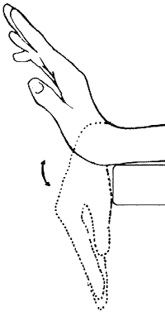Move the hand upward until you feel a gentle stretch.
  + Return to the starting position and repeat the same steps on the other side.

**Wrist supination**

* + Sit on a table with your arm at your side
  + Bend your elbow to 90 degrees and make sure your palm is facing down
  + Rotate your forearm, so that your palm faces up and then down.

**Wrist deviation exercise**

* + Place your forearm on a table, use a rolled-up towel to support your arm
  + Move the wrist up and down

**Thumb flexion/extension**

* + Position your thumb outward and slowly move it across the palm
  + Return to the starting position and then repeat the same step

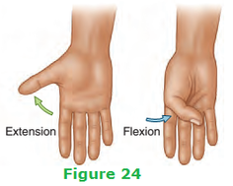

**Hand/finger tendon glide**

* + Extend your fingers straight out and make a hook fist
  + 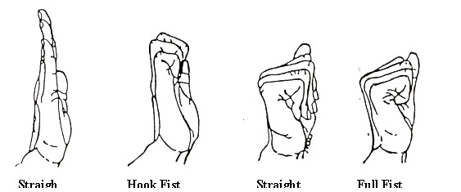Return to starting position and then make a full fist

## Beat Gout Pain with Water Walking

If you’re looking for a great summer workout, leave your gym shoes and go for water exercises instead. That’s right. Swimming and water walking are becoming increasingly popular among gout sufferers. In fact you can find water walking classes popping up across the country and for a very good reason.

Aquatic Coordinator for a popular fitness center in Dallas suggests that like all water exercises, water walking is also easy on the joints. This means water would support your body weight which ultimately reduces stress on your gout affected joints.

The good thing is that water exercises provide almost 12 times the resistance of air. So even if you’re walking comfortable in water, you will be strengthening your joints and building muscle. Remember that you don’t really need any extra weight for water exercises. All you have to do is use your own body weight to start building muscle.

Exercising in warm pool in particular is trending these days. Medical experts also suggest that water walking in warm pools is a good exercise for people with painful and damaged joints.

There are several benefits of water walking for gout, which include:

1. Water reduces the stress or impact on joints
2. Walking in water improves cardiovascular fitness as well as body balance and range of motion
3. Heated or warmer pools can help soothe the painful joints. Walking in cooler water might not make your achy joints feel as good, but you can at least reap the benefits of a good workout.
4. Water is known to have greater resistance than air. This means walking in water requires more effort and you can burn more calories than working out on ground.

Many fitness centers and community pools have special programs designed for people with gout and arthritis. Water classes basically fall into three major categories:

1. Interval training – walking or exercise period will be followed by periods of rest

2. Continuous training

3. Station classes – water walking workouts are combined with strength training exercises

If you’re new to water exercise or don’t know how to swim, there’s nothing to worry about. Water walking classes can be followed by anyone including non-swimmers. You can ask your instructor for help if you’re in love with water walking and swimming.

### Deep Water Walking

You can use a flotation belt for assistance during deep water walking. This belt will help you walk upright the same way you would walk on the ground.

For deep water walking, you will be required to stand in water about chest height and walk through the pool the same way you walk on the ground. Make sure you stand upright with your shoulder back and your arms placed on the sides.

When you start, place your foot on the bottom of the pool firmly (instead of just your forefoot) with your heel coming down first. Making slow strides, walk across the pool and lift your knees to boost your workout.

To make water walking a little more intense, you can try pumping your arms and legs at a faster rate and then return to your normal pace.

Pay close attention to your posture as you walk in water – your back shouldn’t be bent.

You can easily avoid problems that accompany gym and other outdoor workouts by exercising in a pool such as dehydration. But remember that you still need to drink water even if you’re walking in a cool pool.

## Gentle Strength Training Exercises for People with Gout

If you have gout, exercises such as low-impact aerobics, strength training, and stretching can help prevent stiff joints, build muscle, improve endurance, and benefit your heart, bones, and mood. Of course, regular physical exercise is beneficial, but when joints are inflamed, you need to take it easy.

Studies suggest that you should rest during a flare-up and listen to your body. If you feel good to just walk around, go ahead and don’t push through strength training. Also work closely with your doctor to find the right strength training exercise for you. Needless to say, you should consult your doctor immediately if your symptoms become worse after exercise.

### Chair Stand

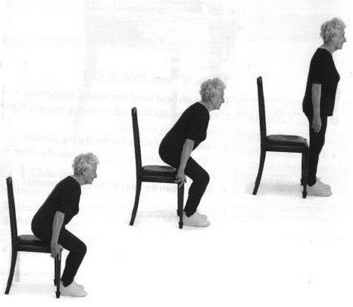This exercise is great for people who want to build their leg muscles. All you have to do is sit in a normal height chair and stand up and sit down. However don’t just sit – instead try to control your movements.

Try to complete at least 10 to 15 reps and perform the exercise 2 to 3 times a day.

To make the moves more challenging, try a ‘taller’ chair and control your motion more with your legs and less with your arms.

### Yoga Stretches

You can benefit from yoga even if you have tender, swollen joints. Remember, gentle yoga stretching is great for improving joint mobility. However you should avoid power yoga, hot or Bikram yoga or other intense yoga moves that might put excessive pressure on the joints.

### Pilates

Pilates can help you achieve fitness goals in a way that is ideal for gout. Interestingly Pilates are ideal moves because they include low impact, flowing movements that promote joint health.

Those of you who are familiar with Pilates would know that the movements revolve around a central stabilized core which is your pelvis and spine. During Pilates, you will be encouraged to move at your own pace and listen to your body.

# Chapter Five: Managing Gout with Lifestyle Changes

If you have been diagnosed with gout, you can make lifestyle change that might help lower the risk of future acute flare-ups. As stated earlier, gout is a painful form of arthritis where sharp, needle like uric acid crystals start depositing in your joints. The continuous buildup of uric acid crystals causes severe pain, swelling and inflammation. While urate crystals most commonly affect the big toe, they can deposit in other joints as well including your knee, ankles and wrist.

Uric acid production is a natural physiological process. Your body breaks down substances found in your tissue to produce uric acid. Furthermore, the food you need might contain purines which are also metabolized to produce uric acid.

Like other substances, uric acid dissolves in your blood and is excreted via the kidneys. But problems can arise when your kidney doesn’t flush out uric acid and your blood uric acid levels start increasing.

**Lifestyle Changes to Manage Gout**

In addition to healthy, balanced diet, there are a number of other helpful steps that can help you manage gout.

**1. Know your uric acid levels**

Make sure you get your uric acid levels checked at least twice a year. Ideally your reading should be below 6 mg/dL.

**2. Regular exercise**

Even 30 minutes of moderate intensity physical activity every day can prevent weight gain and reduce your chances of developing gout attack. According to the Center for Disease Control and Prevention, you can talk with your doctor to develop an appropriate exercise program that is tailored to your body, lifestyle and needs.

**3. Maintain healthy body weight**

An overweight person is almost 4 times more likely to develop gout than a person with ideal body weight. Remember, you don’t have to take extreme measures such as crash dieting to lose weight fast because this can increase the amount of uric acid levels in blood.

Talk to your dietician and determine the best plan of action. Also, make sure you avoid high-protein diets containing purine rich foods such as red meat and oily fish which can trigger gout attacks by increasing uric acid levels in blood.

**4. Stay hydrated**

Experts suggest that you should consume at least 64 ounces of water daily and even more if you’re exercising. Staying hydrated can help your kidneys flush out the toxins and excess uric acid from the blood stream. Drinking adequate water would also lubricate your joints and guard your body against kidney stones and constipation.

5. Opt for low-calorie diets

Research shows that one of the most helpful ways to prevent gout attacks is to maintain healthy body weight. If you lose weight, you can lower stress on your joints and significantly reduce your risk of gout attacks.

So the question is ‘what diet should you follow in order to lose weight?’ Well, traditional thinking was that you should reduce the intake of purine rich foods to decrease the risk of acute flare-ups. But recent studies suggest that following a low-purine diet is not enough.

That’s right. Reducing your intake of purines is never enough to cure gout. What you need to do instead is lower your calorie intake. Yes, you’ve guessed it right. You need to eliminate all kinds of refined carbohydrates from your diet and this includes all kinds of sugar, white flour and other processed foods.

Make sure your diet contains more fruits, vegetables, whole grains and fat-free/low-fat dairy. You can get your protein intake from plant based sources because they will protect you against gout.

You also need to limit your intake of meat and poultry – the maximum allowed quantity is 4 to 6 ounces a day.

Studies have also shown that drinks that are rich in fructose can increase the risk of gout attacks. Furthermore drinking alcohol is also a significant risk factor, so limit the amount of beer, wine, fruit flavored drinks and sodas you drink or avoid them completely.

Chapter Six: Natural remedies to treat Gout

There’s a strong chance that you don’t want to try prescription drugs to treat the painful arthritic condition known as gout. Well, sadly gout is something that affects more and more people every day. But before you lose all hope, you need to understand that there are a number of simple home remedies that Okinawans have used for centuries to help with gout symptoms.

If you have gout, the first thing you have to do is eliminate refined carbohydrates, sugars and alcohol from your diet as well as red meat. You also need to stay away from purine rich foods and begin eating plenty of fresh fruits and low purine vegetables.

Changing your diet and lifestyle is the easiest solution to beating gout. And now here are the top ten home remedies that can help you get rid of gout for good.

**1. Apple Cider Vinegar**

Apple cider vinegar or ACV can help relieve acute joint pain. You can add a teaspoon of raw ACV to a glass of water and drink it two to three times daily to reduce your body’s inflammatory response.

Once the remedy starts working, you can gradually increase the dosage of ACV to up to 2 tbsp in one glass of water.

**2. Celery Juice**

Medical experts have identified more than a dozen different types of antioxidants that are responsible for the anti-inflammatory effects of celery. You can use your juicer to produce fresh celery juice for getting rid of gout.

**3. Ginger root**

The anti-inflammatory properties of ginger are well-known and ginger root has been used for the treatment of gout since ages.

Mix equal amounts of turmeric powder, dried ginger root powder and fenugreek powder and use 1 tsp of this mixture twice a day. All you have to do is mix 1 tsp of the powder with one glass warm water and drink it twice a day.

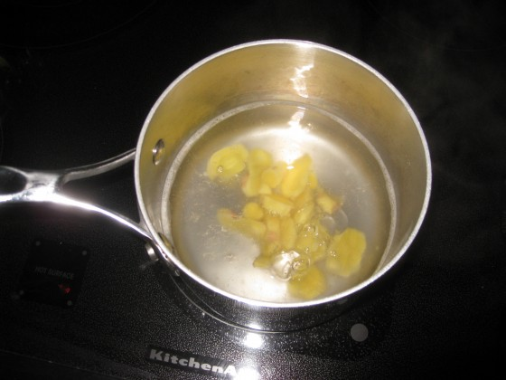For quick relief from joint stiffness, add ½ tsp of fresh ginger root to one cup of boiling water and mix well. You need to drink this solution at least once a day to relieve pain and inflammation and prevent gout from coming back.

**4. Baking soda**

Mix ½ tsp of baking soda in a glass of water and drink this solution 3 to 4 times a day, but never more than that. Continue the treatment up to two weeks.

Caution:

You shouldn’t use baking soda if you’re over 60 or you suffer from hypertension.

**5. Cherry juice**

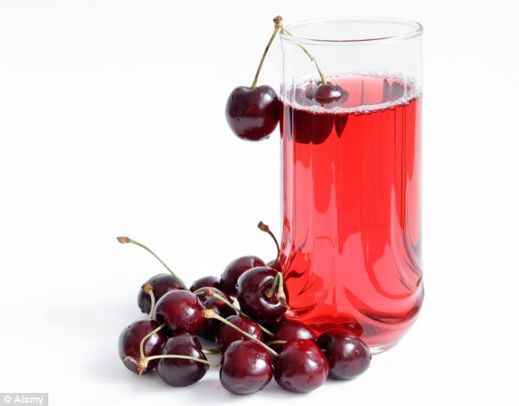Like celery, cherries are also packed with powerful antioxidants (mainly anthocyanins) which can reduce the pain and inflammation associated with gout. For best results, drink a glass of fresh black cherry juice every day. You should also try eating 15 to 20 cherries a day to treat gout.

Studies suggest that cherry intake is associated with a lower risk of gout attacks.

*This* [*study*](http://onlinelibrary.wiley.com/doi/10.1002/art.34677/abstract) *included 633 individuals with gout. Cherry intake over a 2-day period was associated with a 35% lower risk of gout attacks compared with no intake (multivariate OR 0.65 [95% CI 0.50–0.85]). Cherry extract intake showed a similar inverse association (multivariate OR 0.55 [95% CI 0.30–0.98]). The effect of cherry intake persisted across subgroups stratified by sex, obesity status, purine intake, alcohol use, diuretic use, and use of anti-gout medications. When cherry intake was combined with allopurinol use, the risk of gout attacks was 75% lower than during periods without either exposure (OR 0.25 [95% CI 0.15–0.42]).[6]*

**6. Lemon Juice/Vitamin C**

As stated earlier, it is important to alkalize the blood and neutralize the excess uric acid to get relief from gout pain. And this can be done fairly easily by using lemon juice.

Mix the juice of half a lemon with a glass of water and drink it at least three times a day.

[Numerous studies also show that vitamin C intake can help prevent one of the most common forms of arthritis, i.e. gout.](http://www.webmd.com/arthritis/news/20090309/vitamin-c-may-help-prevent-gout)

*Researchers found men who had the highest vitamin C intake from supplements and food were up to 45% less likely to develop the painful condition than those who had the lowest.*

*Researcher Hyon K. Choi, MD, formerly of the University of British Columbia, Vancouver, and now of the Boston University School of Medicine, and colleagues say other studies have suggested that vitamin C appears to prevent gout by reducing levels of uric acid in the blood. Buildup of uric acid can lead to the formation of crystals, which can deposit in the body, leading to the pain, inflammation, and swelling associated with gout.*

*In the study, published in the Archives of Internal Medicine, researchers analyzed the relationship between vitamin C intake and gout among 46,994 healthy men from 1986 to 2006. The men answered questionnaires detailing vitamin C intake through diet and/or vitamin C supplements every four years.*

*During the study period, 1,317 new cases of gout were diagnosed among the participants.*

*The results showed that those with higher vitamin C intake had a consistently lower risk of developing gout than others. For example, men with a vitamin C intake of 1,500 milligrams or more per day had a 45% lower risk of gout compared with those who had a vitamin C intake of less than 250 milligrams per day.*

*Nearly all the men who had vitamin C intakes over 500 milligrams per day took vitamin C supplements. Researchers found that for every 500 milligrams of vitamin C the men took, the risk of gout was reduced by an additional 15%.*

*Researchers say the results suggest that taking vitamin C supplements at the levels in the study (less than 2,000 milligrams per day) may be a safe and effective way to prevent gout.* [7]

**7. Epsom Salt**

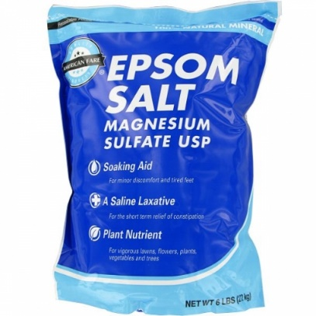The high amount of magnesium present in Epsom salt can decrease uric acid formation in the body and lower your risk of developing gout. It is also a good idea to add magnesium rich foods and magnesium supplements to your diet as they’re very beneficial in treating gout.

Soaking the affected joint in warm water containing Epsom salt can relax aching muscles and relieve pain. That’s right. You can add two cups of Epsom salt to your warm bath water and enjoy a leisurely soak two or three times a week.

**8. Bananas**

The high potassium content in bananas can help convert uric acid levels into dissolvable form that can easily be excreted via the kidneys. Bananas also contain moderate amounts of vitamin C which is very effective in managing pain and swelling.

Simply eat 1 to 2 bananas daily and you will soon notice improvement in your symptoms.

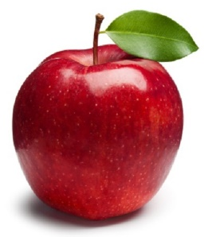**9. Apples**

The Malic acid present in apples is what helps get rid of uric acid in blood. If you don’t like to eat apples, drink a glass of fresh apple juice daily to relieve gout pain and inflammation.

**10. Activated Charcoal**

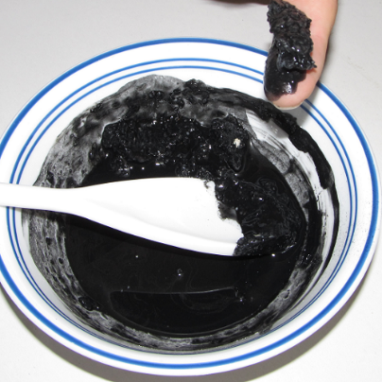Activated charcoal is an excellent absorbent and it can be used safely for gout treatment. Mix ½ cup of activated charcoal powder with water to form a thick paste. You need to dissolve this paste in bath water and let your body soak for at least half an hour.

If you’re not comfortable with charcoal baths, apply the charcoal paste directly on the affected joint and let it rest for about 30 minutes. You can then rinse it off with Luke warm water.

# Conclusion

Now that we have reached the end of this eBook, here’s hoping that you know what needs to be done in order to get relief from the pain and inflammation associated with gout naturally. More importantly, with this information you will be able to make sure you never have another painful gout attack.

Follow the recommendations in this book along with a healthy overall lifestyle, you should be pain free from gout within no time.

**References – Studies/Research**

1. Gout – Centers for Disease Control and Prevention

<http://www.cdc.gov/arthritis/basics/gout.html>

2. Alcohol increases the risk of gout – Harvard Health Publications

<http://www.health.harvard.edu/family-health-guide/alcohol-increases-the-risk-of-gout>

3. Wine Implicated in Gout Flares – Arthritis Foundation

<http://blog.arthritis.org/gout/wine-gout-flares/>

4. The Best Diet Advice for Gout: Eat Less Meat – Arthritis Foundation

<http://www.arthritis.org/about-arthritis/types/gout/articles/purine-foods-gout-attack.php?_ga=1.18025786.2047234926.1473065888>

5. Sugary Drinks and Obesity Fact Sheet – Harvard School of Public Health

<https://www.hsph.harvard.edu/nutritionsource/sugary-drinks-fact-sheet/>

6. 5 exercises to improve hand mobility - Harvard Health Publications

<http://www.health.harvard.edu/pain/5-exercises-to-improve-hand-mobility-and-reduce-pain>

7. Cherry consumption and decreased risk of recurrent gout attacks –

<http://onlinelibrary.wiley.com/doi/10.1002/art.34677/abstract>

8. Vitamin C May Help Prevent Gout

<http://www.webmd.com/arthritis/news/20090309/vitamin-c-may-help-prevent-gout>

9. Gout - U.S. Department of Health and Human Services Public Health Service

<http://www.niams.nih.gov/health_info/gout/gout_ff.pdf>

10. All about gout and diet – UK Gout Society

<http://www.ukgoutsociety.org/docs/goutsociety-allaboutgoutanddiet-0113.pdf>

11. Gout Causes, Symptoms and Treatment – the Arthritis Society

<https://arthritis.ca/getmedia/be21a71d-a605-4d70-a48a-bfc14c35e0ca/Gout.pdf?ext=.pdf>

12. Preventing Gout Attacks – Palo Alto Medical Foundation

<http://www.pamf.org/handouts/gout.pdf>

13. PATHOPHYSIOLOGY OF GOUT

<http://www.helmberg.at/gout.pdf>

14. Gout – An Update

<http://www.aafp.org/afp/2007/0915/p801.pdf>

15. The 4 Stages of Gout

<https://healthguides.healthgrades.com/article/the-4-stages-of-gout>

16. The pathogenesis of Gout

<http://www.the-aps.org/mm/Publications/Journals/PIM/choi-pdf.pdfappear>

17. Types of Gout Exercises

<http://www.move.org.au/Conditions-and-Symptoms/Gout/Exercise>

18. Exercise helps ease arthritis pain and stiffness

<http://www.mayoclinic.org/diseases-conditions/arthritis/in-depth/arthritis/art-20047971>

19. Gout symptoms – Arthritis Foundation

<http://www.arthritis.org/about-arthritis/types/gout/symptoms.php>

20. How to Exercise with Gout

<http://www.healthcentral.com/chronic-pain/exercise-515640-5.html>

1. <http://www.cdc.gov/arthritis/basics/gout.html>
2. <http://blog.arthritis.org/gout/wine-gout-flares/>
3. <http://www.arthritis.org/about-arthritis/types/gout/articles/purine-foods-gout-attack.php?_ga=1.18025786.2047234926.1473065888>
4. <https://www.hsph.harvard.edu/nutritionsource/sugary-drinks-fact-sheet/>
5. <http://www.health.harvard.edu/pain/5-exercises-to-improve-hand-mobility-and-reduce-pain>
6. <http://onlinelibrary.wiley.com/doi/10.1002/art.34677/abstract>
7. Vitamin C May Help Prevent Gout <http://www.webmd.com/arthritis/news/20090309/vitamin-c-may-help-prevent-gout>